Exercise



1.

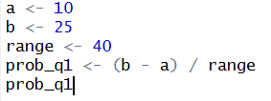

2.

3.

i)

ii)

